SIMATS ENGINEERING
ASSESSMENT TOOL 1 – High (Coding Challenge)
COURSE CODE: CSA09 COURSE NAME: Programming in Java
COURSE OUTCOME COVERED
CO1: Apply object-oriented programming principles such as classes, objects, encapsulation, data hiding, inheritance, and polymorphism to design and implement entity manipulations (BL3,BL4)
QUESTIONS: 5 Total Marks: 100
ANNEXURE A Coding Challenge
Code of Conduct:
I N.Bhavya shree(192572039)(Name / Reg No) certify that this submission is my original work and that I have adhered to the guidelines specified for this assessment. I understand that any violation of academic integrity rules will result in disciplinary action.
Signature of the student:N.Bhavya shree
RUBRICS FOR CALCULATION:
Criteria | Weightage | Level 4 (Exemplary) | Level 3 (Proficient) | Level 2 (Developing) | Level 1 (Beginning)
Problem Understanding | 20% | Clearly understands problem  constraints, edge cases, and  competitive requirements | Understands problem with  minor gaps in  constraints | Partial understanding; misses key constraints | Misinterprets problem or constraints
Algorithm | 25% | Selects optimal algorithm with best  time and space  complexity for  competitive constraints | Uses efficient algorithm with  minor scope for improvement | Uses  basic/inefficient approach | No clear algorithmic approach
Code Implementation | 20% | Writes correct, efficient, and clean  code that passes all constraints | Code works with minor errors or  inefficiencies | Partially correct code; fails for some cases | Code does not execute or gives incorrect results
Competitive  Performance | 20% | Solves problem within time limits  and handles large inputs effectively | Solves within acceptable time with minor delays | Struggles with time limits or larger inputs | Unable to solve within time constraints
Test Case  Handling | 15% | Handles all test cases including  edge and hidden cases | Handles most test cases | Misses important edge cases | Fails on multiple test cases

ANNEXURE
Coding Challenge

1. Library Book Management using Classes & Encapsulation
Design a Book class with private fields such as bookId, title, author, and price. Implement constructors, getters, setters, and methods to issue and return books. Create a menu-driven program to manage multiple books using an array of objects. Also, construct suitable test cases to validate book addition, issue, return, and search operations. BTL: BL3 (Apply)
CODE:
import java.util.*;

class Book {
private int bookId;
private String title;
private String author;
private double price;
private boolean issued;

public Book(int bookId, String title, String author, double price) {
this.bookId = bookId;
this.title = title;
this.author = author;
this.price = price;
this.issued = false;
}

public int getBookId() {
return bookId;
}

public String getTitle() {
return title;
}

public void issueBook() {
if (!issued) {
issued = true;
System.out.println("Book Issued Successfully.");
} else {
System.out.println("Book already issued.");
}
}

public void returnBook() {
if (issued) {
issued = false;
System.out.println("Book Returned Successfully.");
} else {
System.out.println("Book was not issued.");
}
}

public void display() {
System.out.println(bookId + " " + title + " " + author + " " + price + " " + (issued ? "Issued" : "Available"));
}
}

public class LibraryManagement {
public static void main(String[] args) {
Scanner sc = new Scanner(System.in);

Book books[] = new Book[10];
int count = 0;

while (true) {
System.out.println("\n1.Add Book");
System.out.println("2.Display");
System.out.println("3.Search");
System.out.println("4.Issue");
System.out.println("5.Return");
System.out.println("6.Exit");

int ch = sc.nextInt();

switch (ch) {

case 1:
System.out.print("Book ID: ");
int id = sc.nextInt();
sc.nextLine();

System.out.print("Title: ");
String title = sc.nextLine();

System.out.print("Author: ");
String author = sc.nextLine();

System.out.print("Price: ");
double price = sc.nextDouble();

books[count++] = new Book(id, title, author, price);
break;

case 2:
for (int i = 0; i < count; i++)
books[i].display();
break;

case 3:
System.out.print("Enter Book ID: ");
id = sc.nextInt();

for (int i = 0; i < count; i++)
if (books[i].getBookId() == id)
books[i].display();
break;

case 4:
System.out.print("Book ID:");
id = sc.nextInt();

for (int i = 0; i < count; i++)
if (books[i].getBookId() == id)
books[i].issueBook();
break;

case 5:
System.out.print("Book ID:");
id = sc.nextInt();

for (int i = 0; i < count; i++)
if (books[i].getBookId() == id)
books[i].returnBook();
break;

case 6:
System.exit(0);
}
}
}
}
OUTPUT:
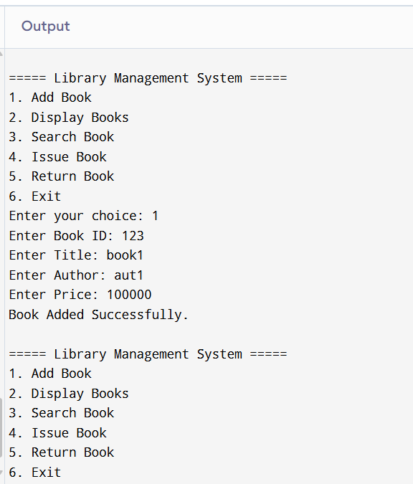

2. Employee Payroll System using Inheritance
Design a payroll system with a base class Employee and derived classes PermanentEmployee and ContractEmployee. Override a method calculateSalary() in each subclass to compute salary differently. Display employee details and salary using runtime polymorphism. Also, construct suitable test cases to validate salary calculation for different employee types. BTL: BL3 (Apply)
CODE:
import java.util.*;

public class Employee {

public static void main(String args[]) {

Scanner sc = new Scanner(System.in);

System.out.println("1. Permanent Employee");
System.out.println("2. Contract Employee");
System.out.print("Enter Choice: ");
int ch = sc.nextInt();

System.out.print("Enter Employee ID: ");
int id = sc.nextInt();

sc.nextLine();

System.out.print("Enter Employee Name: ");
String name = sc.nextLine();

double salary = 0;

switch(ch) {

case 1:
System.out.print("Enter Basic Salary: ");
double basic = sc.nextDouble();
salary = basic + (basic * 20 / 100);
break;

case 2:
System.out.print("Enter Working Hours: ");
int hours = sc.nextInt();

System.out.print("Enter Rate per Hour: ");
double rate = sc.nextDouble();

salary = hours * rate;
break;

default:
System.out.println("Invalid Choice");
return;
}

System.out.println("\nEmployee Details");
System.out.println("Employee ID : " + id);
System.out.println("Employee Name : " + name);
System.out.println("Salary : " + salary);
}
}
OUTPUT:
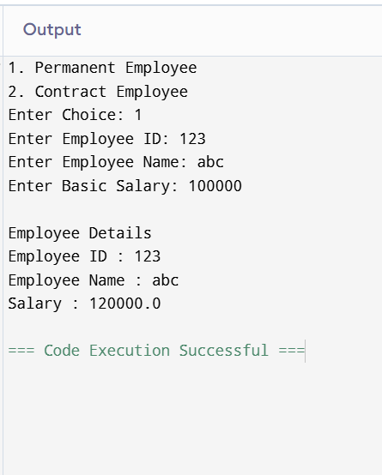

3. Vehicle Rental System using Runtime Polymorphism
Develop a vehicle rental system with a superclass Vehicle and subclasses Car, Bike, and Bus. Override the method calculateRent(int days) in each subclass. Store vehicles in an array of Vehicle references and generate rental bills dynamically. Also, construct suitable test cases to validate rent calculation for different vehicle categories. BTL: BL4 (Analyze)
CODE:
import java.util.*;

public class Vehicle {

public static void main(String args[]) {

Scanner sc = new Scanner(System.in);

System.out.println("1. Car");
System.out.println("2. Bike");
System.out.println("3. Bus");
System.out.print("Enter Choice: ");

int ch = sc.nextInt();

System.out.print("Enter Number of Days: ");
int days = sc.nextInt();

double rent = 0;

switch(ch) {

case 1:
rent = days * 1000;
break;

case 2:
rent = days * 500;
break;

case 3:
rent = days * 3000;
break;

default:
System.out.println("Invalid Choice");
return;
}

System.out.println("Rental Amount = " + rent);
}
}
OUTPUT:
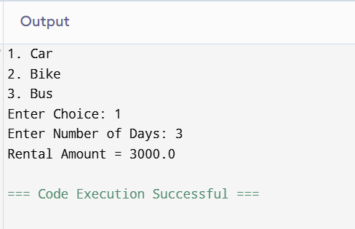

4. Bank Account System using Data Hiding
Design a BankAccount class with private fields accountNumber, holderName, and balance. Implement methods for deposit, withdrawal, and balance inquiry with proper validation. Prevent direct modification of balance from outside the class. Also, construct suitable test cases to validate valid and invalid transactions. BTL: BL3 (Apply)
CODE:
import java.util.*;

public class BankAccount {

public static void main(String args[]) {

Scanner sc = new Scanner(System.in);

int accountNumber = 1001;
String holderName = "Lavanya";
double balance = 5000;

while(true) {

System.out.println("\n1.Deposit");
System.out.println("2.Withdraw");
System.out.println("3.Balance");
System.out.println("4.Exit");

System.out.print("Enter Choice: ");
int ch = sc.nextInt();

switch(ch) {

case 1:

System.out.print("Enter Deposit Amount: ");
double deposit = sc.nextDouble();

if(deposit > 0) {
balance += deposit;
System.out.println("Deposit Successful");
}
else
System.out.println("Invalid Amount");

break;

case 2:

System.out.print("Enter Withdraw Amount: ");
double withdraw = sc.nextDouble();

if(withdraw <= balance) {
balance -= withdraw;
System.out.println("Withdrawal Successful");
}
else
System.out.println("Insufficient Balance");

break;

case 3:

System.out.println("Account Number : " + accountNumber);
System.out.println("Holder Name : " + holderName);
System.out.println("Balance : " + balance);

break;

case 4:
System.exit(0);

default:
System.out.println("Invalid Choice");
}
}
}
}
OUTPUT:
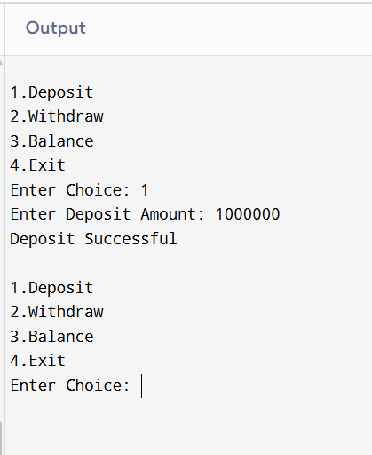

5. University Admission System using Method Overloading
Create an Admission class that overloads the method calculateFee() for:
- Undergraduate students,
- Postgraduate students,
- Scholarship students.
Display the fee structure based on user input and compare the overloaded method executions. Also, construct suitable test cases to validate each overloaded version. BTL: BL3 (Apply)
CODE:
import java.util.*;

public class Admission {

public static void main(String args[]) {

Scanner sc = new Scanner(System.in);

System.out.println("1. Undergraduate");
System.out.println("2. Postgraduate");
System.out.println("3. Scholarship Student");

System.out.print("Enter Choice: ");
int ch = sc.nextInt();

double fee = 0;

switch(ch) {

case 1:
fee = 50000;
System.out.println("UG Fee = " + fee);
break;

case 2:
fee = 70000;
System.out.println("PG Fee = " + fee);
break;

case 3:
fee = 50000;

System.out.print("Enter Scholarship Amount: ");
double scholarship = sc.nextDouble();

fee = fee - scholarship;

System.out.println("Scholarship Fee = " + fee);
break;

default:
System.out.println("Invalid Choice");
}
}
}
OUTPUT:
